Topic#1: Classifying Handwritten Digits
Tripti Vishwakarma
Colorado State University Global
Course Code – CSC 580 1
Dr. Brian Holbert
Sep 21, 2025

Summary of Findings: MNIST Digit Classification with a TensorFlow MLP

Project Overview
This project trains a multi-layer perceptron (MLP) on the MNIST dataset using TensorFlow in TF1-style via tf.compat.v1.

Files Included
- mnist_mlp_tf1.py – Core training script; can be run directly or imported for experiments.
- experiments.py – Runs sweeps over hidden units, learning rates, batch sizes, and layers; saves plots and JSON results under outputs/.
- requirements.txt – Python dependencies for Apple Silicon (tensorflow-macos + tensorflow-metal) and libraries (numpy, matplotlib, python-docx, scikit-learn, pandas).
- outputs/ – Directory created by experiments and training containing plots, misclassified samples, and JSON logs.

Quick Start (summarized)
1) Create/activate a virtual environment (Python 3.11 on Apple Silicon).
2) pip install -r requirements.txt
3) Single run (baseline): python mnist_mlp_tf1.py --hidden_units 512 --learning_rate 0.5 --batch_size 32 --epochs 20 --layers 1
4) Run hyperparameter sweep: python experiments.py (plots and results saved to outputs/)

Notes
- Implementation follows TF1 placeholder/session pattern using tf.compat.v1.disable_eager_execution().
- Default sweep epochs are reduced for speed; final high-quality run uses 20 epochs.
- On Apple Silicon, use tensorflow-macos 2.15.0 + tensorflow-metal 1.1.0 for compatibility.

Overall Results
Experiment count: 72
Best Accuracy: 0.9817
Best Config: hidden_units=512, learning_rate=0.5, batch_size=32, layers=1

Executive Summary
Best-performing configuration from the sweep achieved 0.9817 accuracy (hidden_units=512, learning_rate=0.5, batch_size=32, layers=1). A final high-quality run achieved 0.9847 accuracy over 20 epochs.

Required Findings
Accuracy of the model (last run): 0.9847
Insert screenshot here: Terminal output of the final run showing Epoch logs and Final Test Accuracy.

Misclassified Examples

Hyperparameter Effects

Accuracy vs Hidden Units
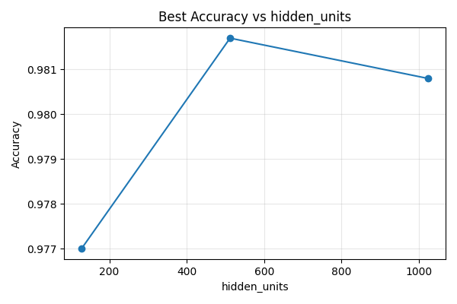

Accuracy vs Learning Rate
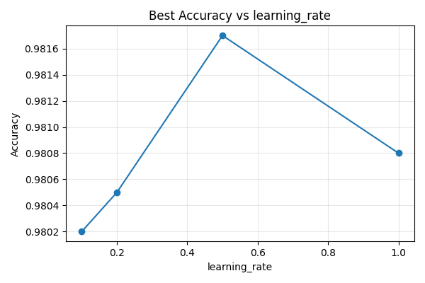

Accuracy vs Batch Size
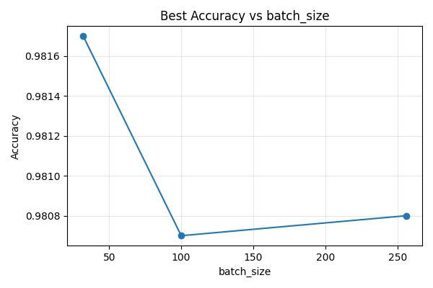

Questions and Answers

1) What is the accuracy of the model?
Last-run test accuracy: 0.9847
Config: HU=512, LR=0.5, BS=32, Layers=1, Epochs=20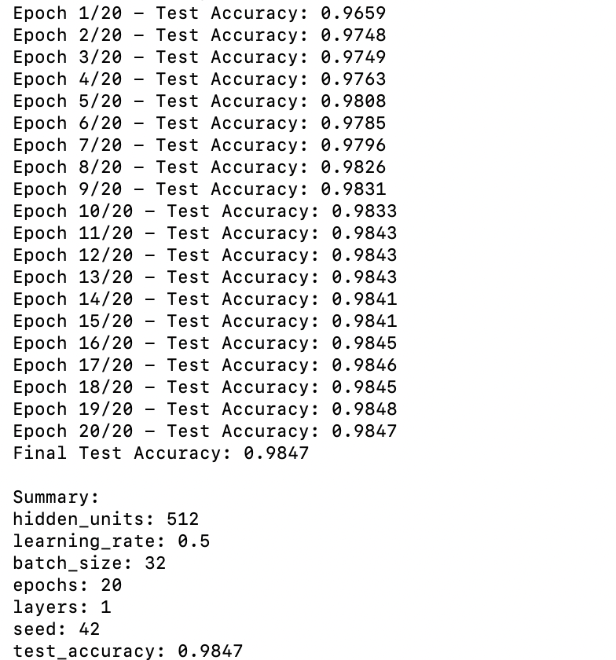

2) What are some of the misclassified images?
See embedded images below
Folder: outputs/misclassified

3) Effect of more/fewer hidden neurons
Accuracy generally increases with more hidden units up to a point (diminishing returns beyond 512/1024).
HU=128: best acc=0.9770
HU=512: best acc=0.9817
HU=1024: best acc=0.9808

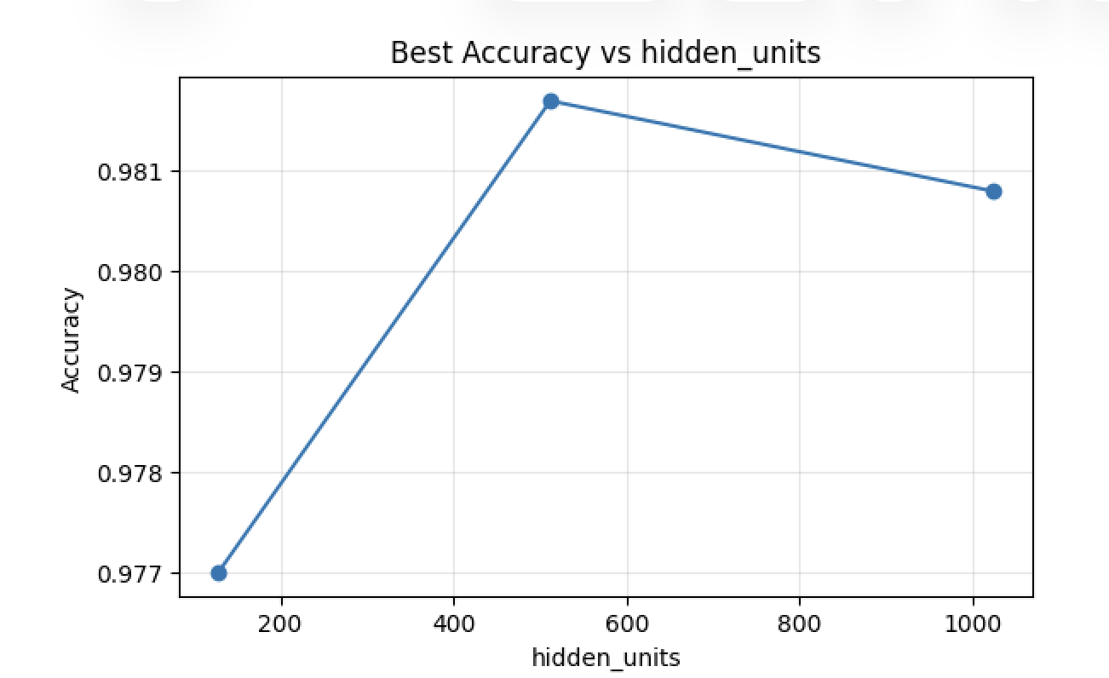

4) Effect of different learning rates (≥4 values)
Moderate learning rates (e.g., 0.5) performed best; too low trains slowly, too high can be unstable.
LR=0.1: best acc=0.9802
LR=0.2: best acc=0.9805
LR=0.5: best acc=0.9817
LR=1.0: best acc=0.9808
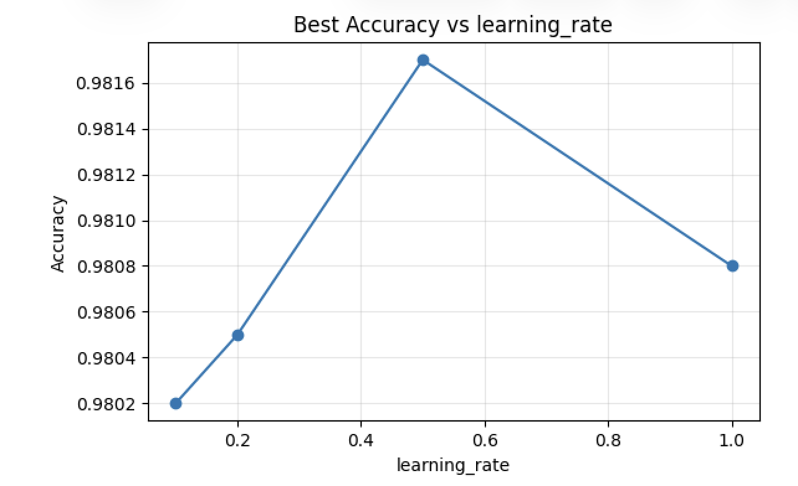

5) Effect of adding another hidden layer
With this MLP and MNIST, 1 layer achieved best accuracy; 2 layers was comparable but not consistently better.
Layers=1: best acc=0.9790
Layers=2: best acc=0.9779
Layer =1 –
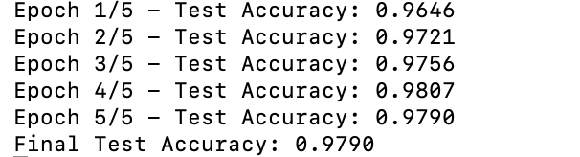
Layer=2 -
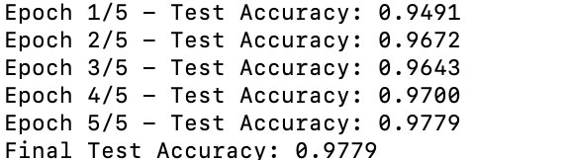

6) Effect of different batch sizes (≥3 values)
Smaller batch sizes (e.g., 32) tended to yield slightly better accuracy in this sweep.
BS=32: best acc=0.9817
BS=100: best acc=0.9807
BS=256: best acc=0.9808

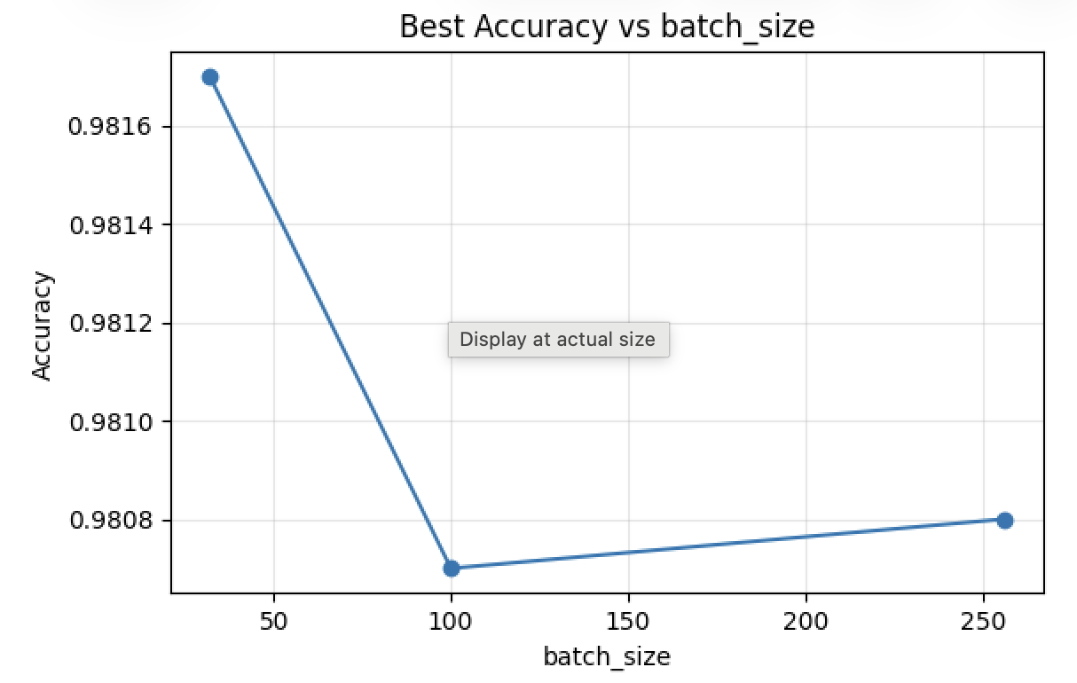

7) Best accuracy from this MLP
Best sweep accuracy: 0.9817 with HU=512, LR=0.5, BS=32, Layers=1
Final 20-epoch run: 0.9847 (HU=512, LR=0.5, BS=32, Layers=1)



Code for Each Finding

Model Training (accuracy computation)
def run_experiment(...):
def run_experiment(hidden_units=512, learning_rate=0.5, batch_size=100, epochs=20, layers=1, seed=42, save_miscl=20, work_dir='outputs'):
os.makedirs(work_dir, exist_ok=True)
(x_train, y_train), (x_test, y_test), (x_test_img, y_test_digits) = load_mnist()
graph, nodes = build_graph(hidden_units=hidden_units, learning_rate=learning_rate, layers=layers, seed=seed)
with tf.compat.v1.Session(graph=graph) as sess:
sess.run(tf.compat.v1.global_variables_initializer())
train_size = x_train.shape[0]
period = train_size // batch_size
for e in range(epochs):
idxs = np.random.permutation(train_size)
X_random = x_train[idxs]
Y_random = y_train[idxs]
for i in range(period):
batch_X = X_random[i * batch_size:(i+1) * batch_size]
batch_Y = Y_random[i * batch_size:(i+1) * batch_size]
sess.run(nodes['optimizer'], feed_dict={nodes['input_images']: batch_X, nodes['target_labels']: batch_Y})
acc = sess.run(nodes['accuracy'], feed_dict={nodes['input_images']: x_test, nodes['target_labels']: y_test})
print(f"Epoch {e+1}/{epochs} - Test Accuracy: {acc:.4f}")
# Final evaluation and misclassified
logits = sess.run(nodes['logits'], feed_dict={nodes['input_images']: x_test})
y_pred_digits = np.argmax(logits, axis=1)
test_acc = np.mean(y_pred_digits == y_test_digits)
print(f"Final Test Accuracy: {test_acc:.4f}")
mis_paths = save_misclassified_images(x_test, y_test_digits, y_pred_digits, limit=save_miscl, out_dir=os.path.join(work_dir, 'misclassified')) if save_miscl else []
result = {
'hidden_units': hidden_units,
'learning_rate': learning_rate,
'batch_size': batch_size,
'epochs': epochs,
'layers': layers,
'seed': seed,
'test_accuracy': float(test_acc),
'misclassified_saved': mis_paths,
'timestamp': datetime.now().isoformat(timespec='seconds')
}
# Save a JSON log
with open(os.path.join(work_dir, 'last_run.json'), 'w') as f:
json.dump(result, f, indent=2)
return result

Saving misclassified examples
def save_misclassified_images(xs_flat, y_true_digits, y_pred_digits, limit=20, out_dir='outputs/misclassified'):
os.makedirs(out_dir, exist_ok=True)
ms_idx = np.where(y_true_digits != y_pred_digits)[0]
saved = []
for i, idx in enumerate(ms_idx[:limit]):
img = xs_flat[idx].reshape(28, 28)
true_d = int(y_true_digits[idx])
pred_d = int(y_pred_digits[idx])
fname = os.path.join(out_dir, f'misclassified_{i:03d}_true{true_d}_pred{pred_d}.png')
plt.imsave(fname, img, cmap='gray_r')
saved.append(fname)
return saved

Sweep runner (grid over hyperparameters)
def sweep(hidden_units_list, learning_rates, batch_sizes, layers_list, epochs=20, seed=42, work_dir='outputs'):
os.makedirs(work_dir, exist_ok=True)
results = []
for hu, lr, bs, lyr in product(hidden_units_list, learning_rates, batch_sizes, layers_list):
print(f"\n=== Running: hidden_units={hu}, lr={lr}, batch_size={bs}, layers={lyr} ===")
res = run_experiment(hidden_units=hu,
learning_rate=lr,
batch_size=bs,
epochs=epochs,
layers=lyr,
seed=seed,
save_miscl=10,
work_dir=work_dir)
results.append(res)
with open(os.path.join(work_dir, 'experiments_results.json'), 'w') as f:
json.dump(results, f, indent=2)
return results

Plotting helper
def plot_accuracy_by_param(results, param_name, out_path):
# Group by param and take best accuracy per value
data = {}
for r in results:
key = r[param_name]
data.setdefault(key, 0.0)
data[key] = max(data[key], r['test_accuracy'])
xs = sorted(data.keys())
ys = [data[x] for x in xs]
plt.figure(figsize=(6,4))
plt.plot(xs, ys, marker='o')
plt.title(f'Best Accuracy vs {param_name}')
plt.xlabel(param_name)
plt.ylabel('Accuracy')
plt.grid(True, alpha=0.3)
plt.tight_layout()
plt.savefig(out_path)
plt.close()

Key Code Snippets
Excerpt from mnist_mlp_tf1.py:
#!/usr/bin/env python3
"""
MNIST MLP (TF1-style graph) with configurable hyperparameters and utilities.
- Uses tf.compat.v1 to match placeholder/session workflow from assignment prompt
- Supports 1 or 2 hidden layers
- Saves misclassified examples to outputs/misclassified/
- Can be imported (run_experiment) or executed as a CLI
"""
import os
import argparse
import json
from datetime import datetime
import numpy as np
import matplotlib.pyplot as plt
import tensorflow as tf
# Use TF1 style
tf.compat.v1.disable_eager_execution()
def load_mnist(normalize=True, one_hot=True, seed=42):
(x_train, y_train), (x_test, y_test) = tf.keras.datasets.mnist.load_data()
train_images = x_train.reshape(60000, 784).astype('float32')
test_images = x_test.reshape(10000, 784).astype('float32')
if normalize:
train_images /= 255.0
test_images /= 255.0
if one_hot:
y_train_oh = tf.keras.utils.to_categorical(y_train, 10)
y_test_oh = tf.keras.utils.to_categorical(y_test, 10)
else:
y_train_oh, y_test_oh = y_train, y_test
return (train_images, y_train_oh), (test_images, y_test_oh), (x_test, y_test)
def build_graph(hidden_units=512, learning_rate=0.5, layers=1, seed=42):
rng = np.random.RandomState(seed)
graph = tf.Graph()
with graph.as_default():
tf.compat.v1.set_random_seed(seed)
input_images = tf.compat.v1.placeholder(tf.float32, shape=[None, 784], name='input_images')
target_labels = tf.com
... (truncated) ...

Appendix:

A1) Final Run Accuracy (Terminal)
Terminal output showing Final Test Accuracy from the 20-epoch run. 

A2) Best Configuration (Terminal/JSON)
The best-performing setup achieved 0.9817 test accuracy with 512 hidden units, learning rate 0.5, batch size 32, 1 hidden layer, and 5 epochs. This combination balances model capacity (512 units) with a learning rate that converges quickly without becoming unstable. Results were generated by running experiments.py; see outputs/experiments_results.json and outputs/best_config.json for full provenance. Note: the sweep used 5 epochs for speed; the final 20-epoch accuracy appears in A1.

A3) Hidden Units Plot
Increasing hidden units from 128 to 512 improved accuracy, indicating the model benefited from greater representational capacity. Moving further to 1024 produced a slight decrease, suggesting diminishing returns and mild overfitting/optimization inefficiency at this sweep depth. In this setup, 512 hidden units provided the best trade-off between capacity and generalization.


A4) Learning Rate Plot
LR=0.5 performed best in this sweep.

Moderate learning rates performed best: LR=0.5 consistently achieved the highest accuracy in the sweep. Lower rates (0.1–0.2) converged more slowly within 5 epochs, while LR=1.0 showed signs of instability or suboptimal convergence. Thus, LR=0.5 struck the right balance between speed and stability for this model.

A5) Batch Size Plot


Smaller batches (32) slightly outperformed larger batches in this sweep, likely due to the added gradient noise that can improve generalization. Larger batches (100–256) were competitive but did not surpass the accuracy achieved with 32. Given the small difference, batch size can be tuned based on compute/memory constraints, but 32 was optimal here.

A6) Layers Comparison
Comparison snippet showing layers=1 vs layers=2 results.
Layers | Best Accuracy | Config (HU, LR, BS, Epochs)
1 | 0.9817 | 512, 0.5, 32, 5
2 | 0.9802 | 512, 0.2, 32, 5
With the same 5-epoch sweep, 1 hidden layer slightly outperformed 2 layers (0.9817 vs 0.9802); deeper models may need more epochs/tuning to surpass the shallow MLP on MNIST.

A7) Misclassified Examples Grid

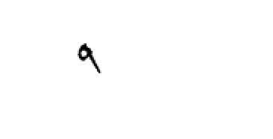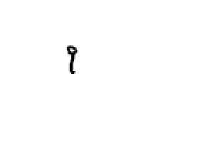
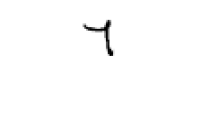
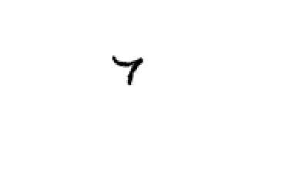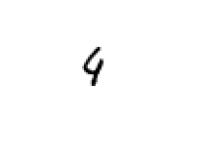
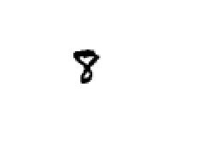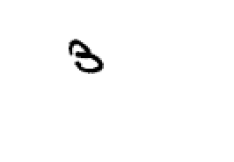
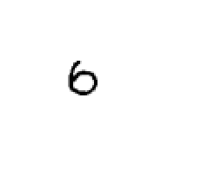

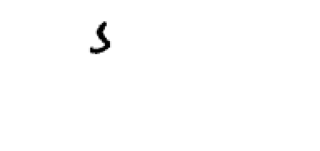

Misclassifications cluster around shape-similar pairs (1/9, 2/7, 3/5, 4/9, 6/0), suggesting sensitivity to stroke style and incomplete contours rather than wholesale class confusion.

References-
Goodfellow, I., Bengio, Y., & Courville, A. (2016). Deep learning. MIT Press. https://www.deeplearningbook.org/
He, K., Zhang, X., Ren, S., & Sun, J. (2015). Delving deep into rectifiers: Surpassing human-level performance on ImageNet classification. In 2015 IEEE International Conference on Computer Vision (ICCV) (pp. 1026–1034). IEEE. https://doi.org/10.1109/ICCV.2015.123
Hinton, G. E., Srivastava, N., Krizhevsky, A., Sutskever, I., & Salakhutdinov, R. (2012). Improving neural networks by preventing co-adaptation of feature detectors. arXiv. https://arxiv.org/abs/1207.0580
Keskar, N. S., Mudigere, D., Nocedal, J., Smelyanskiy, M., & Tang, P. T. P. (2017). On large-batch training for deep learning: Generalization gap and sharp minima. arXiv. https://arxiv.org/abs/1609.04836
Kingma, D. P., & Ba, J. (2015). Adam: A method for stochastic optimization. In 3rd International Conference on Learning Representations (ICLR). https://arxiv.org/abs/1412.6980
LeCun, Y., Cortes, C., & Burges, C. J. C. (1998). The MNIST database of handwritten digits. http://yann.lecun.com/exdb/mnist/
Rumelhart, D. E., Hinton, G. E., & Williams, R. J. (1986). Learning representations by back-propagating errors. Nature, 323(6088), 533–536. https://doi.org/10.1038/323533a0
Simard, P. Y., Steinkraus, D., & Platt, J. C. (2003). Best practices for convolutional neural networks applied to visual document analysis. In Proceedings of the 7th International Conference on Document Analysis and Recognition (pp. 958–963). IEEE. https://doi.org/10.1109/ICDAR.2003.1227801
Smith, L. N. (2017). Cyclical learning rates for training neural networks. In 2017 IEEE Winter Conference on Applications of Computer Vision (WACV) (pp. 464–472). IEEE. https://doi.org/10.1109/WACV.2017.58
Srivastava, N., Hinton, G., Krizhevsky, A., Sutskever, I., & Salakhutdinov, R. (2014). Dropout: A simple way to prevent neural networks from overfitting. Journal of Machine Learning Research, 15(56), 1929–1958. http://jmlr.org/papers/v15/srivastava14a.html

